**08-05-22**

TODAYS AGENDA :-----

* Generating XML reports using Pytest
* Class work on pytest
* What is Jenkins ?
* Whats is CI /CD ?
* Difference between CI & CD
* CLASS TASK----------

1. Use Python Selenium and Pytest for logging into your Instagram account finding your followersand generating a report for the same
2. Use Python Selenium and Pytest for doing web-scrapping on Amazon and generating a report ?
3. Note # Kindly use external files

*******************************************************************

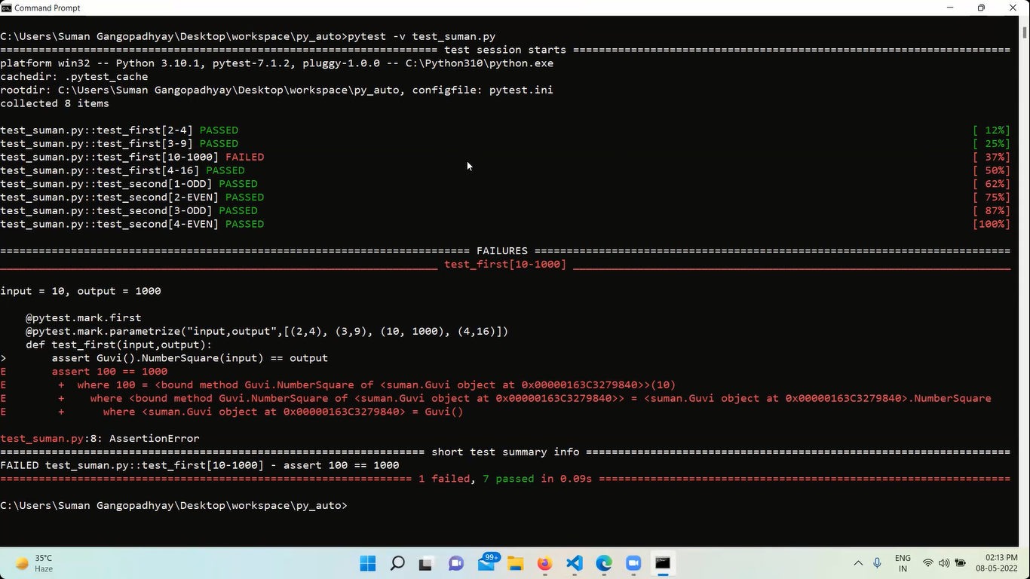

The above pic should be submitted in a file i.e XML file

XML file is needed by the company/developer as it contains the test reports

As a tester you should run tests and you need to create the test reports as XML file

But in unit testing reports

**COMMAND TO GENERATE PYTEST XML REPORT:----**

**pytest –v filesname.py –junitxml=”report.xml”**

eg :---- pytest –v test_suman.py –-junitxml=”report.xml”

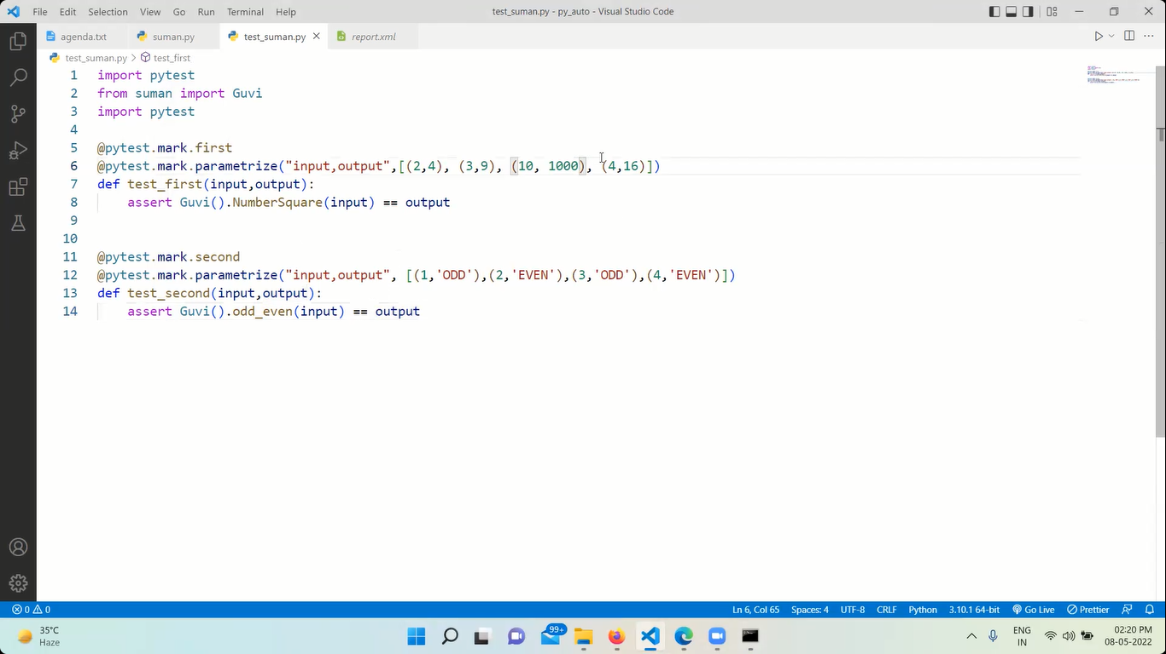

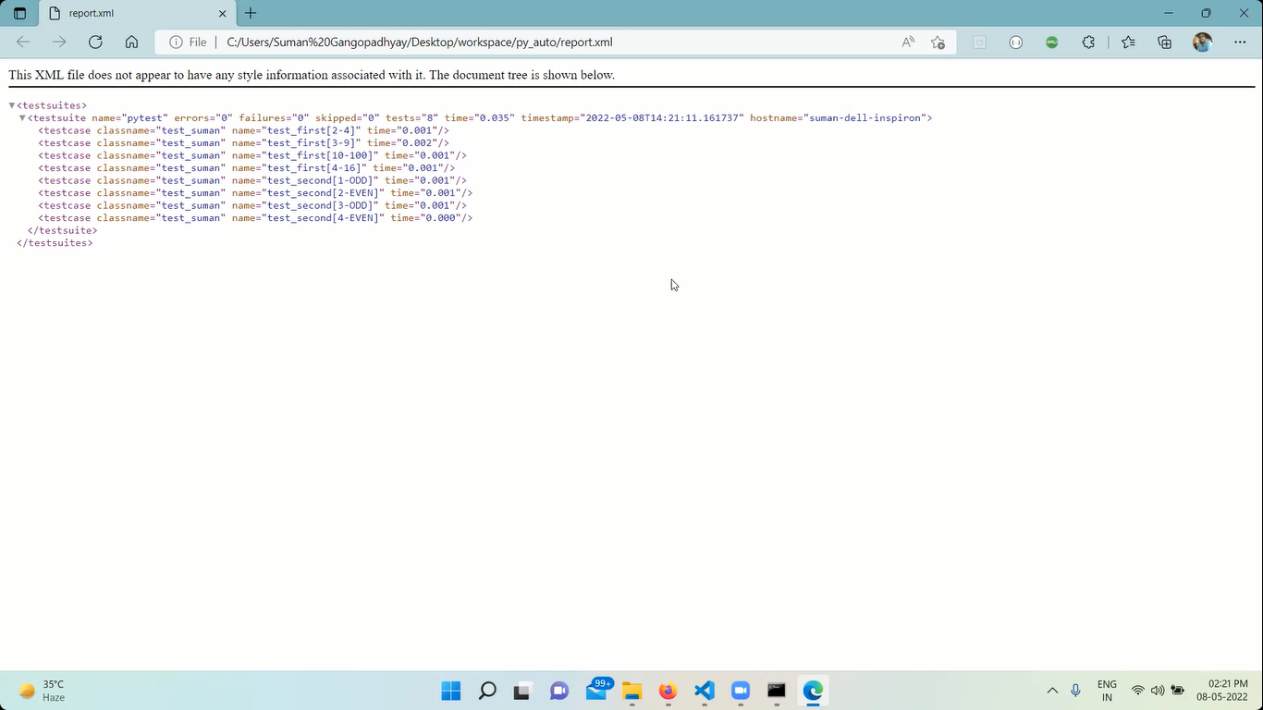

**********************************************

**JENKINS**

Jenkins is an automation server used in the SDLC and STLC for a software lifecycle.

It is written in Java for doing continuous integration, continuous development and deployment of a software.

It runs on Apache Tomcat.

Jenkins accelerates the software development path of a company where it monitors the tasks tested repeatedly and gives us a test report.

Jenkins does CT i.e continuous test on your project builds and gives you a report of builds with errors in the early stages of the development.

**CONTINUOUS INTEGRATION (CI)**

CI is a process of multiple code changes by multiple developers happening multiple times in a single project.

With each commit done after development the code is subjected to testing. If there's any errors/bugs in CI it will go undergo again the SDLC and STLC lifecycle.

This continuous Builds, Tests and Deployment is known as CI / CD.

**HOW JENKINS IS HELPFUL ?**

* Jenkins is a Java based application runs on Apache Tomcat. It runs on OS like Windows, Linux or MacOS and people use it.
* It creates pipelines which are nothing but series of steps that a Jenkins server takes.
* Jenkins CI uses - SERVER, Version Control Tool, Build Tool & Automation frameworks to integrate and work with.

Server - Jenkins

Version Control System - Git / Gitub

Build Tools - Gradle, Maven, ANT

Automation Framework - Selenium, JUnitTest, Pytest